**Secure Food Delivery – User Manual**

Contents

About Secure Food Delivery 3

In the beginning… 3

Mobile Application 4

About mobile app 4

Get Started 4

Login 6

Sign Up 8

How to unlock the device using OTP? 10

How to work with an order list? 10

Error messages 11

Validation Error Messages 11

Smart Delivery Box 12

About Delivery Box 12

RFID Unit 12

Display Unit 12

Locking Unit 13

Access Detection Unit 13

Charging Unit 13

# About Secure Food Delivery

Secure food delivery is an IoT-based solution for food delivery carriers, which enhances the delivery process as well as the trustworthiness of the current process. This is a third-party service for existing services that are based on delivering food.

This concept is based on the third-year undergraduate project of Department of Computer Engineering, Faculty of Engineering, University of Peradeniya. This is a group project of 3 members, Nadeesha Diwakara, Mahela Ekanayake and Lahiru Pathum.

This is the User Manual of the final product. Here any user can get the basic knowledge on how to use our product in frontend software and hardware.

# Mobile Application

## About mobile app

The Secure Food Delivery mobile application is a secure and reliable application that anyone in the world can use to get our secure service. It is designed for 2 roles. They are,

1. Food Customers
2. Delivery Riders

For both food customers and delivery riders, this is the **User Manual** which they might refer to before using it to get the best from it without any confusion.

## Get Started

When you download and install the app, open it. It shows the start page below when opened. Here you can see the landing page of the secure food delivery mobile application.

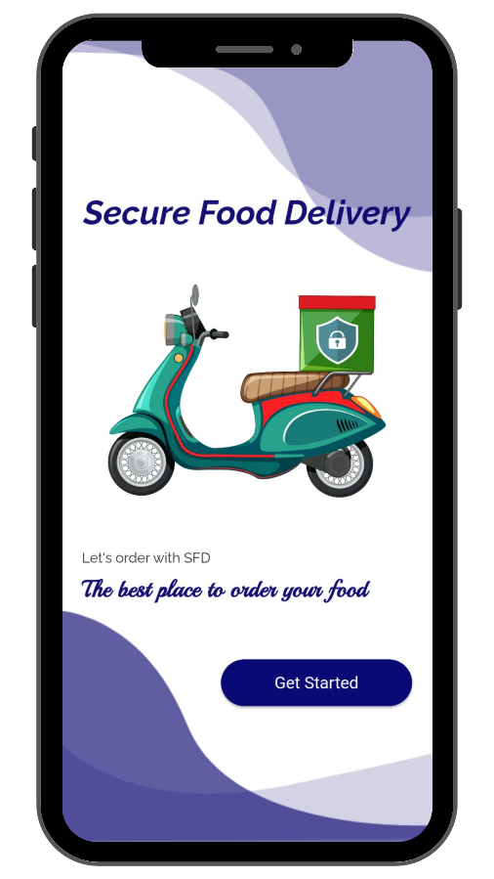

You can get started by tapping on the **Get Started** button. Then you can select the role.

If you are a Food Customer

If you are a food customer who has ordered food and looking to unlock the device using OTP, you can select **Customer.**

Tap here

If you are a Delivery Rider

If you are a delivery rider, select **Rider**.

Tap here

After selecting the role, you will be navigated to the **Login** screen.

## Login

If you are a Food Customer

The login process is divided into two parts.

1. Registered Customer logs in
2. Non-Registered customer login

**Registered customer login:** If have already registered for secure food delivery via the mobile application, that means you are having the RFID card provided by us. Therefore, if you have an RFID card with you, you can either use RFID or a mobile application to unlock the locker. When using the mobile application, provide contact details and order id correctly for login.

**Non-Registered customer login:** Although you haven’t registered for a secure food delivery service, still you can use the mobile application without signing up. You just have to provide your contact number and order ID in the fields shown below and log in to the app. If you want to register and become a pro user, just tap below to sign up. Details for Sign Up can be found in the Sign-Up section.

**Notice:**

When you enter data (contact number, order ID) Please enter valid data. Otherwise, it will show error messages. Please refer to the Error Messages section for more info.

Tap Home icon to return to the Start Screen

Enter the Order ID

Tap to sign up

After providing correct information you can Login from here

Enter your contact number

After login in, you will navigate to the unlock screen where you can use the OTP to unlock the delivery box.

If you are a Delivery Rider

If you are a delivery rider, you can log in to the mobile application, providing contact details and a password if you are a registered rider. If you haven’t registered, refer to the Sign-Up section.

**Notice:**

When you enter data (contact number, password) Please enter valid data. Otherwise, it will show error messages. Please refer to the Error Messages section for more info.

Tap Home icon to return to the Start Screen

Tap to sign up

Enter the Password

After providing correct information you can Login from here

Enter your contact number

After login, you will navigate to the order screen where you can see the orders which have been assigned to you.

## Sign Up

If you are a Food Customer

If you haven’t registered, and want to register, you can signup by tapping on the below text as shown in the left diagram below. After that, the fields will be shown up as shown in the right diagram below. Then, you only have to provide relevant data in the fields and register with the Secure Food Delivery Service as a Customer.

Upon successful registration, you will get an RFID card which can be used to unlock the device instead of the mobile application.

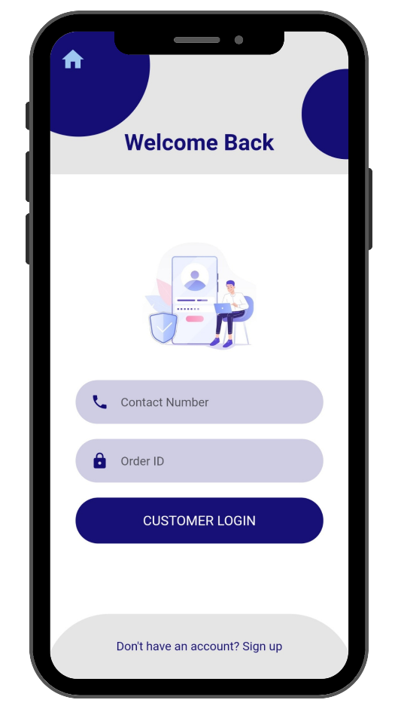

After providing correct information you can register from here

Enter relevant data into the fields to register

Tap to sign up

If you are a Delivery Rider

If you haven’t registered, and want to register, you can signup by tapping on the below text as shown in the left diagram below. After that, the fields will be shown up as shown in the right diagram below. Then, you only have to provide relevant data in the fields and register with the Secure Food Delivery Service as a Customer.

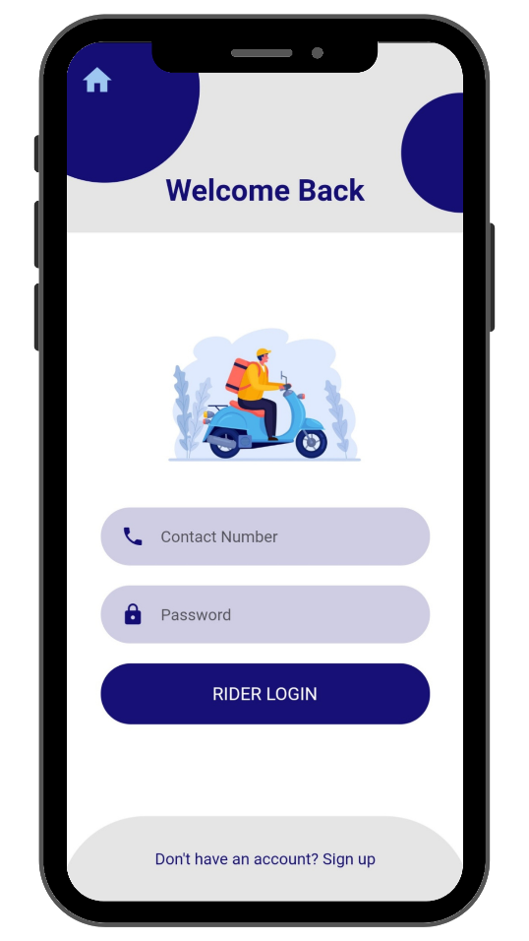

Enter relevant data into the fields to register

After providing correct information you can register from here

Tap to sign up

## How to unlock the device using OTP?

When you got the OTP and the rider have arrived, you can enter the OTP as below and proceed to unlock the device.

Unlock from here

Enter OTP received via SMS

## How to work with an order list?

## Error messages

### Validation Error Messages

These are common error messages that happen when users type the wrong data on the data fields. For example, if you fill in a contact number with less than 10 numbers, it will show a validation error message with red text in the data field. There are some common validation error messages and some of them are shown below.

Check what is the error and refill the field with correct data

If you get any kind of these messages, just check your inputs again and be sure to check that you have entered data in the correct and valid format.

# Smart Delivery Box

## About Delivery Box

This is an IoT-enabled custom-made smart locking device consisting of several security features to ensure the safety of the delivery process. It has some important hardware units, such as a display unit, RFID unit, battery unit, locking unit, and an access detection unit. These units together form the ultimate features of security and reliability. Let’s see them one by one.

## RFID Unit

If there is an RFID card provided to the customer, they can unlock the device using the RFID card instead of the mobile app. The delivery box has an RFID unit embedded in it internally. Therefore, you just have to place the customer’s RFID card in the corresponding place that has been marked on the box.

After placing the RFID card in the correct place, there can be several occurrences as shown below.

1. Customer does not have access.
2. Successfully unlocked.

**Customers do not have access –** if the customer cannot unlock the locker using an RFID card, that means either the customer is not the correct one who ordered the food or else the rider still did not confirm the order from the mobile app. Make sure to confirm the order when the rider has arrived at the customer’s place. If there is any error rather than those mentioned above, please contact Secure Food Delivery immediately. Check the display unit to see what has happened with the unlocking and any important messages. Errors will also display there.

**Successfully unlocked** – if the device has been successfully unlocked, the order will be confirmed as a successful delivery. Check the display unit to see the status of the delivery and any important messages.

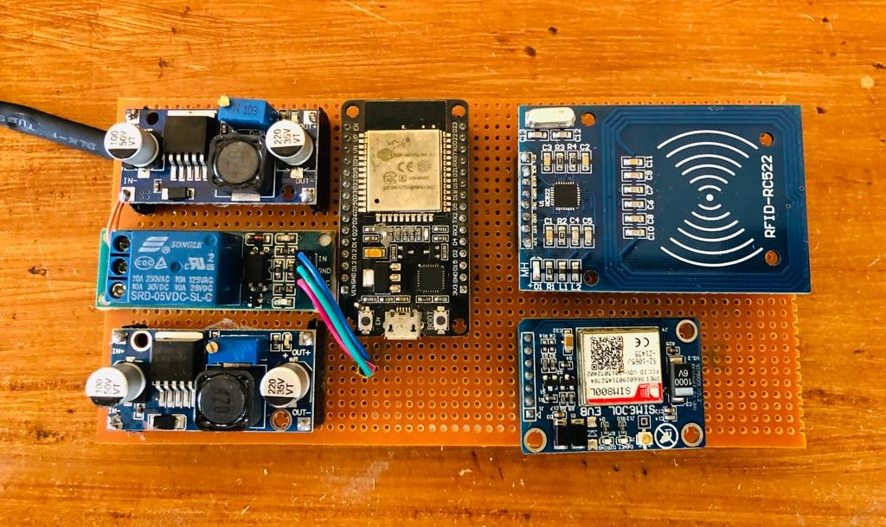

## Display Unit

This is one of the most important parts of the delivery box which is used to show important messages and display status such as battery level, output messages, and so on. The indicating messages can be divided into several parts.

1. Battery level indication.
2. State indication.
3. Error message indication.
4. Unauthorized access indication.

**Battery level indication –** the battery level is a critical parameter in the delivery box design. Therefore, indicating the battery level is important to operate the device. The battery level can be seen in the display as a percentage. It is advisable to recharge the battery when it is below 40%. Be sure to check whether there is enough battery power before going to deliver food. If the battery level is low, recharge the batteries using a battery charger.

**State indication –** there are several states within the delivery process. If the delivery is ongoing, it will show **Ongoing** as the status. If the rider has confirmed the order as having arrived at the destination, the status will be changed to the **Ready to Unlock** state. When the device has unlocked the status will be changed to **Unlocked** state.

**Error message indication –** if there are any errors or restrictions, it also is shown in the display itself. Let’s say that an RFID which is not been assigned to an order is used to unlock the device, it is indicated as an error message that the relevant RFID card is not authorized in the current delivery process. It is straightforward to read and act for error messages. If you have any questions, you must contact Secure Food Delivery.

**Unauthorized access indication –** if there is unauthorized access to the delivery box within the delivery process, it will be indicated as a message on the display. So, the customers and riders can aware of the security threat and take relevant actions based on the unauthorized access.

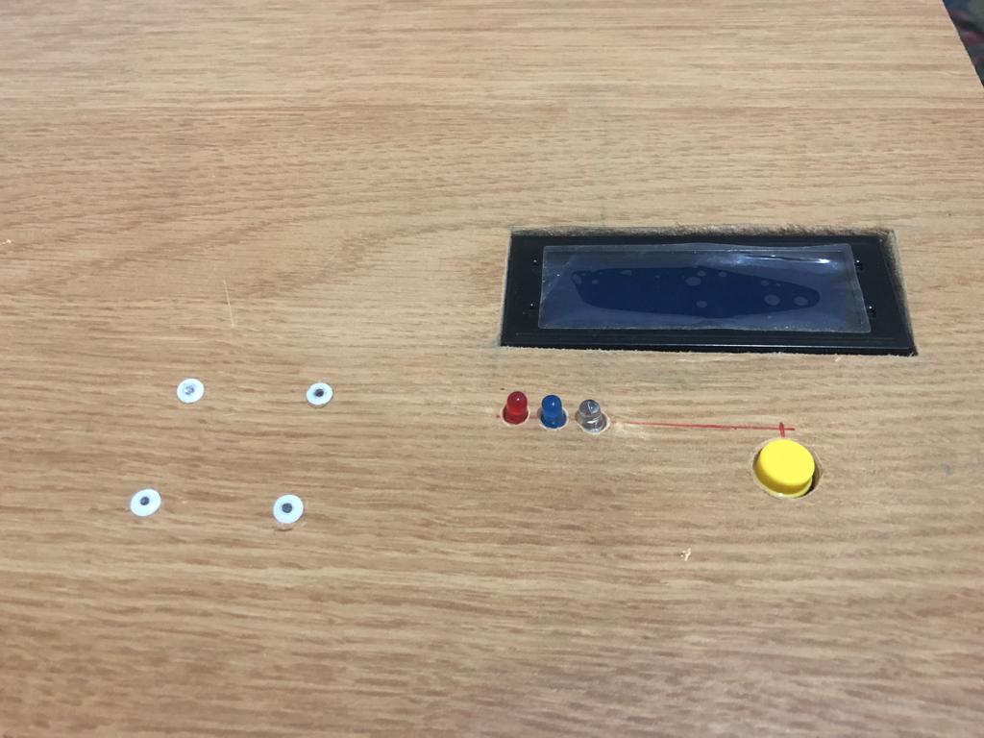

## Locking Unit

The locking unit can be unlocked using either a mobile application or an RFID card. The registered customers have an RFID card such that they can use either way to unlock the device while non-registered customers only have the mobile application to unlock it.

If they use RFID to access the device, it should be placed right on the RFID sensor on the delivery box. When it is unlocked it will indicate on the display too. If the customer uses a mobile app, then they will enter the OTP to unlock the box.

Once the delivery box is opened, please be sure to take the food before closing the lid. Because, if you close the lid while there is food remaining in the box, it will make it impossible to unlock the box using the previous unlocking method. Somehow if you face any problematic situation like this, make sure to press the push button and inform Secure Food Delivery whether there are any orders assigned to the device. If not, you can unlock the device as there are no ongoing deliveries in the box.

## Access Detection Unit

Unauthorized access is detected via sensors. If any access to the device in the middle of the delivery process can be detected and shown in the display and the API will inform the customer about the security violation.

## Charging Unit

When the device is operational, it will consume power. It is advisable to recharge the battery when it is lower than 40%. You can refer to the display to read the battery level and recharge it accordingly. To recharge the unit, power up the charging port to recharge the battery.

